RESULT MANAGEMENT SYSTEM

Toukir Ahammed

Aba kowser

2018

**User Manual**

**Result Management System**

**Course: SE505 Software Project Lab – II**

Submitted by

|  |  |  |
| --- | --- | --- |
| *Toukir Ahammed* | *Roll: 0806* | *2015-2016* |
| *Aba Kowser* | *Roll: 0825* | *2015-2016* |

Document Version 1.0

Submitted to

**SPL II Coordinators**



**Institute of Information Technology**

**University of Dhaka**

[31-05-2018]

Table of Contents

AUTHENTICATION 1

REGISTER 1

LOGIN 3

LOG OFF 4

RECOVER 4

ADMIN PANEL 6

DEPARTMENTS 6

CREATE 6

EDIT 7

DETAILS 7

DELETE 8

COURSES 8

CREATE 9

EDIT 9

DETAILS 10

DELETE 10

STUDENTS 11

CREATE 11

EDIT 12

DETAILS 12

DELETE 13

SEARCH 13

ENROLLMENTS 14

CREATE 14

EDIT 15

DETAILS 15

DELETE 16

SEARCH 16

COURSE ASSIGNMENTS 17

CREATE 17

EDIT 18

DETAILS 18

DELETE 19

PUBLISH RESULT 20

TABULATIONSHEET 20

GENERATE 20

LOGS 21

VIEW AND SEARCH 21

INSTRUCTOR PANEL 23

MYCOURSES 23

COURSE LIST 23

COURSE DETAILS 23

STUDENT LIST 23

MARK SUBMISSION 24

MANAGE SPREADSHEET 24

HOW TO ENTER DATA INTO CELLS 25

HOW TO MOVE FROM CELL TO CELL 25

HOW TO SELECT CELLS 25

HOW TO COPY CELL CONTENTS 25

HOW TO ADD AND DELETE ROWS AND COLUMNS 25

HOW TO DEFINE FORMULA IN CELL 26

CALCULATION OPERATORS 26

OPERATOR ORDER PRECEDENCE 27

HOW TO MERGE CELL 28

RELOAD 28

SAVE 28

AUTOSAVE 28

SUBMIT CONTINUOUS EVALUTION MARKS 28

SUBMIT FINAL EXAMINATION MARK 28

STUDENT PANEL 29

CHECKING RESULT 29

Table of Figures

Figure 1: Default Page 1

Figure 2: Register Link 2

Figure 3: Register Form 2

Figure 4: Confirm Email Message 3

Figure 5: After confirming email Message 3

Figure 6: Login Form 4

Figure 7: Log off 4

Figure 8: Forgot Password Link 5

Figure 9: Forgot Password Form 5

Figure 10: Password Reset Form 6

Figure 11: Department Create, Edit, Details, Delete 6

Figure 12: Department Create Form 7

Figure 13: Department Edit Form 7

Figure 14: Department Details 8

Figure 15: Department Delete Form 8

Figure 16: Course Create, Edit, Details, Delete 9

Figure 17: Course Create Form 9

Figure 18: Course Edit Form 10

Figure 19: Course Details 10

Figure 20: Course Delete 11

Figure 21: Student Create, Edit, Details, Delete, Search 11

Figure 22: Student Create Form 12

Figure 23: Student Edit Form 12

Figure 24: Student Details 13

Figure 25: Student Delete Form 13

Figure 26: Student Search 14

Figure 27: Enrollment Create, Edit, Details, Delete, Search 14

Figure 28: Enrollment Create Form 15

Figure 29: Enrollment Edit Form 15

Figure 30: Enrollment Details 16

Figure 31: Enrollment Delete Form 16

Figure 32: Enrollment Search 17

Figure 33: Course Assignment Create, Edit, Delete, Details 17

Figure 34: Course Assignment Create Form 18

Figure 35: Course Assignment Edit Form 18

Figure 36: Course Assignment Details 19

Figure 37: Course Assignment Delete form 19

Figure 38: Publish Result 20

Figure 39: Result Publication Form 20

Figure 40: Tabulation sheet Generation Form 21

Figure 41: Generated Tabulation Sheet with Print Option 21

Figure 42: View and Search Logs 22

Figure 43: Instructor Courses List 23

Figure 44: See Course Details 23

Figure 45: See Student List 24

Figure 46: Mark Submission 24

Figure 47: Checking Result 29

Figure 48: Result Checking Form 29

Figure 49: Viewing Result 30

Figure 50: Downloading and print page 30

Figure 51: Sample Downloaded Transcript 31

# AUTHENTICATION

Browsing the website as an anonymous user will lead you to the following page.

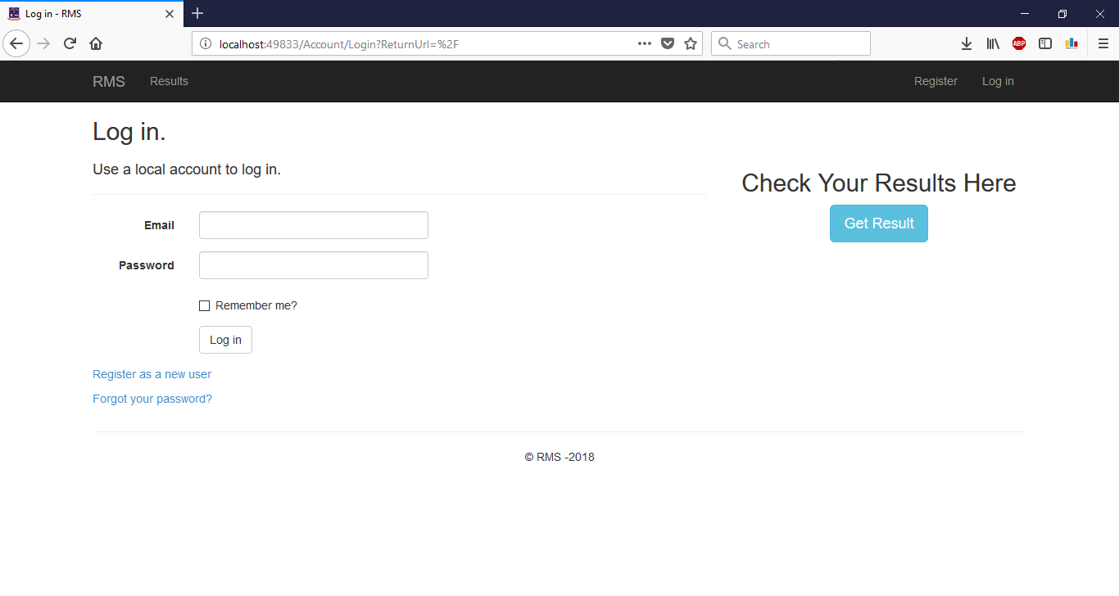

Figure 1: Default Page

## REGISTER

To register as a new user, you have to click the “Register” link. You will be redirect to the register page. After providing the necessary field value you have to click the “Register” button. An email confirmation link will be sent to your email address and you will be redirect to a page saying “Check your email to confirm account”. After clicking the link provided in email you will be able to login.

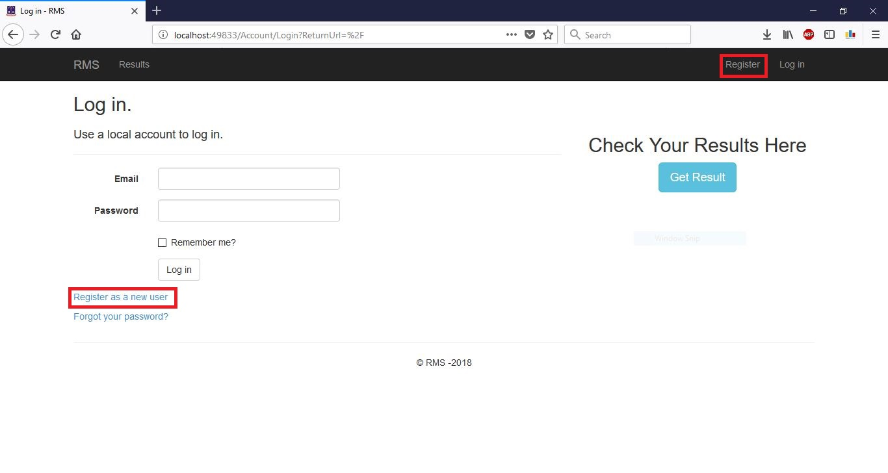

Figure 2: Register Link

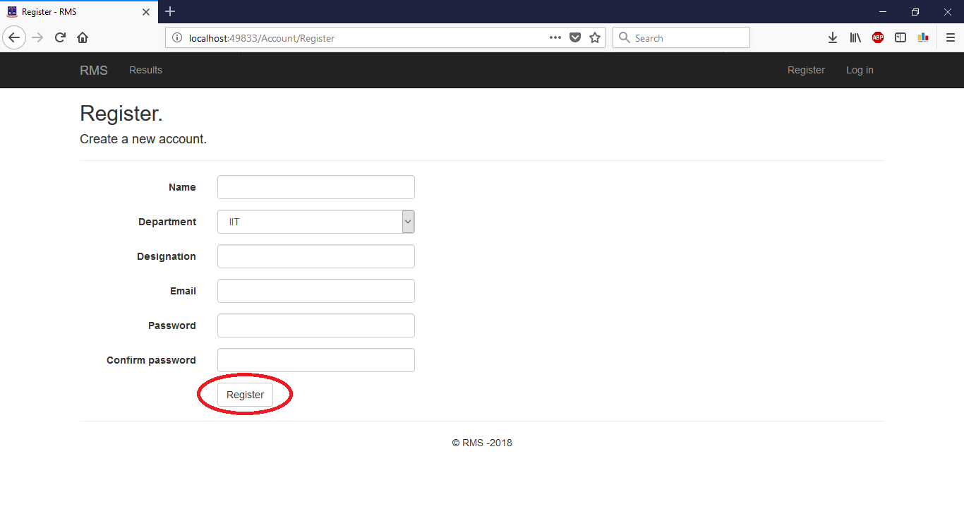

Figure 3: Register Form

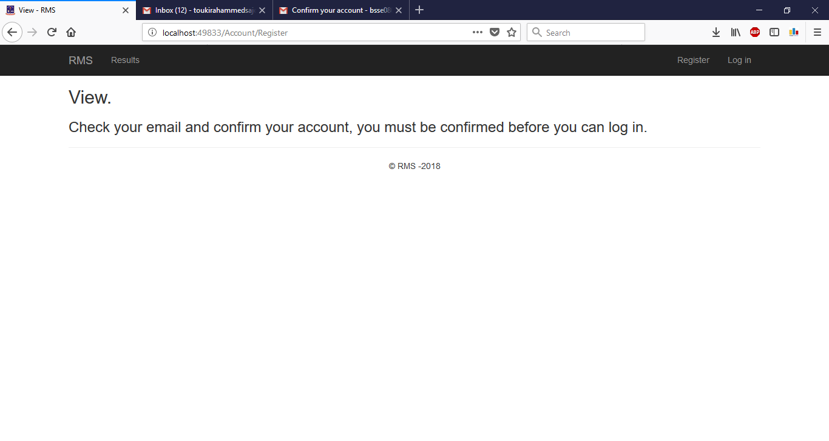

Figure 4: Confirm Email Message

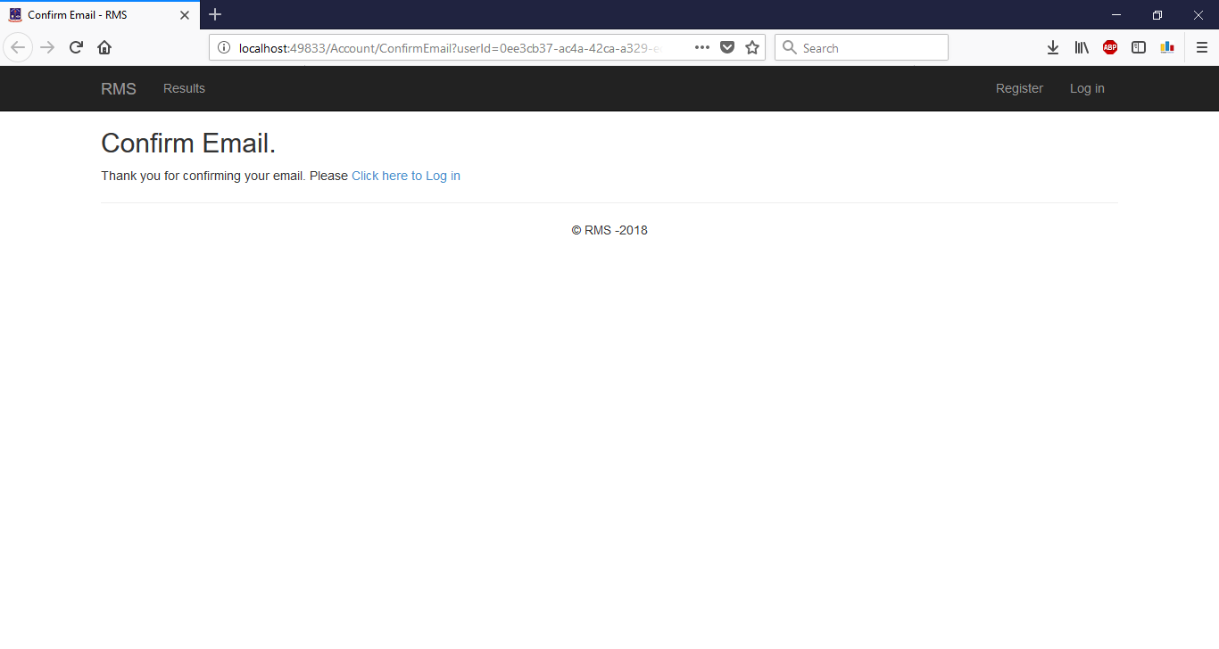

Figure 5: After confirming email Message

## LOGIN

Login page is the default homepage for anonymous user. You can also find the “Login” link from navigation bar. This will redirect you to the login form. After submitting credentials, you will be logged in the system.

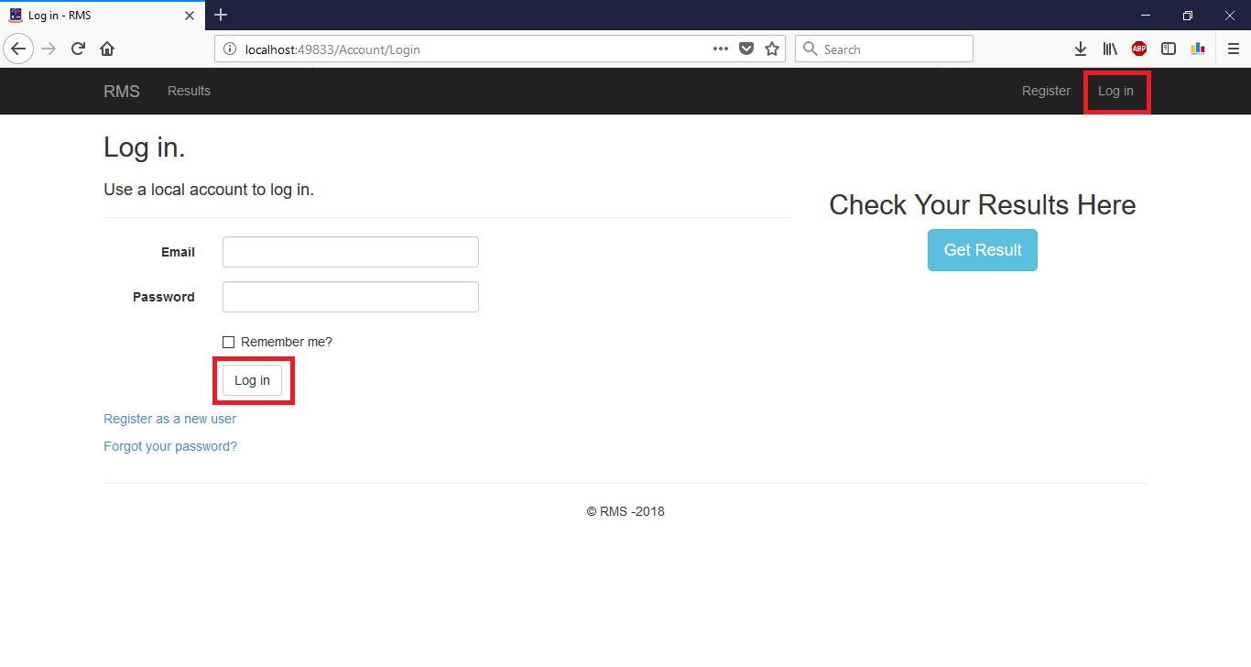

Figure 6: Login Form

## LOG OFF

Any logged in user can find the “Log Off” link in the right upper corner of the navigation bar. By clicking this link, you can log off anytime.

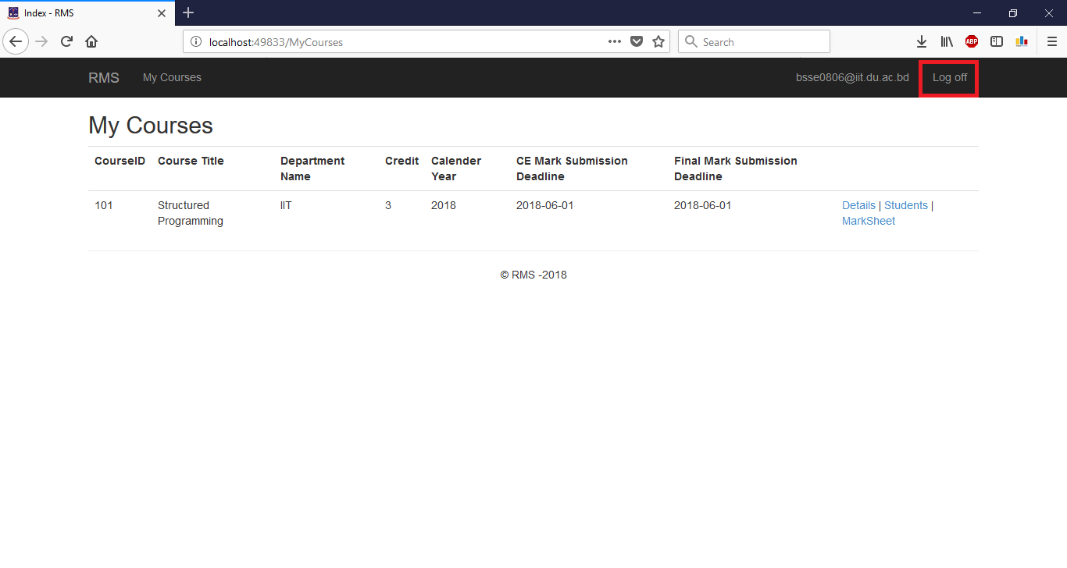

Figure 7: Log off

## RECOVER

In the log in page there is a link in the lower left corner named “Forgot your password”. By clicking this link, the user will be redirected to a page asking for email. After providing email a password reset link will be sent that email address. User can reset password with the provided link.

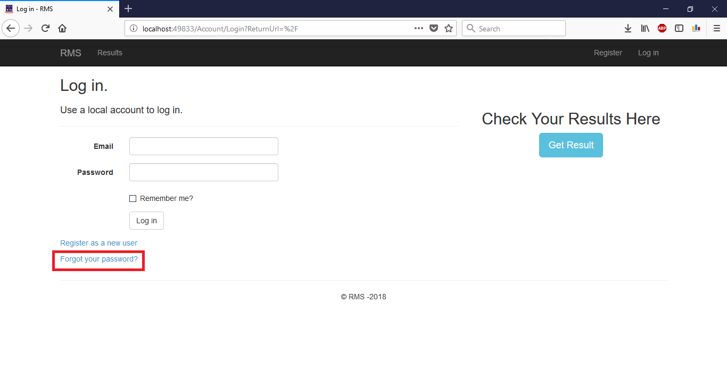

Figure 8: Forgot Password Link

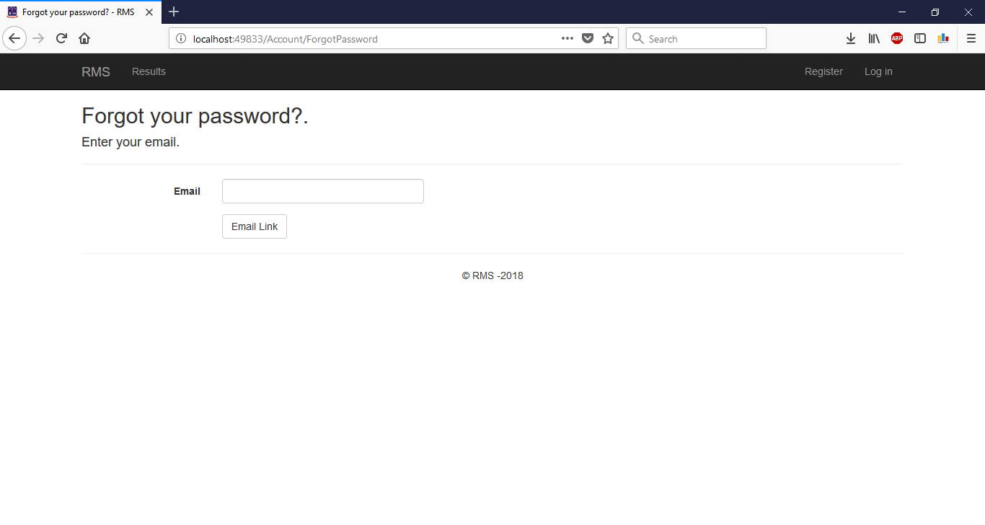

Figure 9: Forgot Password Form

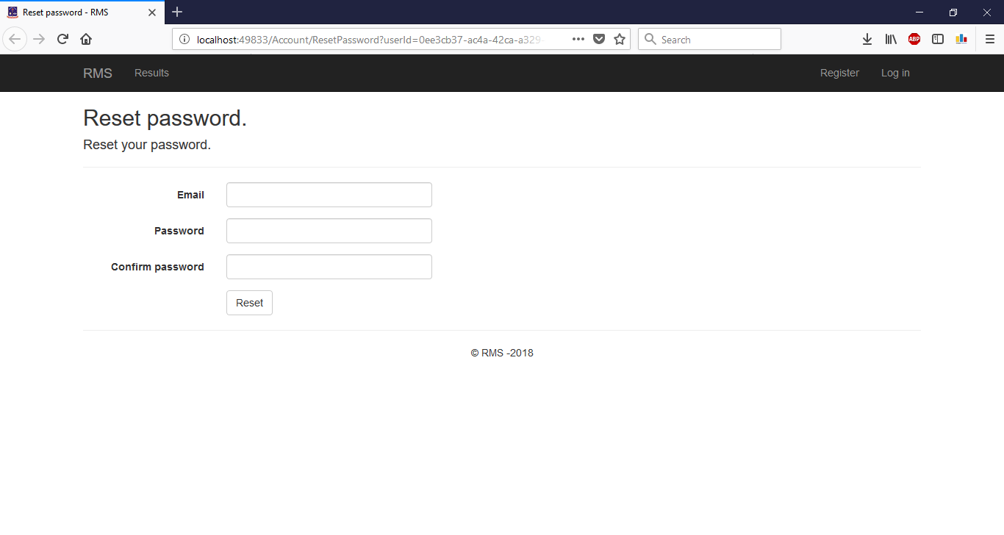

Figure 10: Password Reset Form

# Admin Panel

## Departments

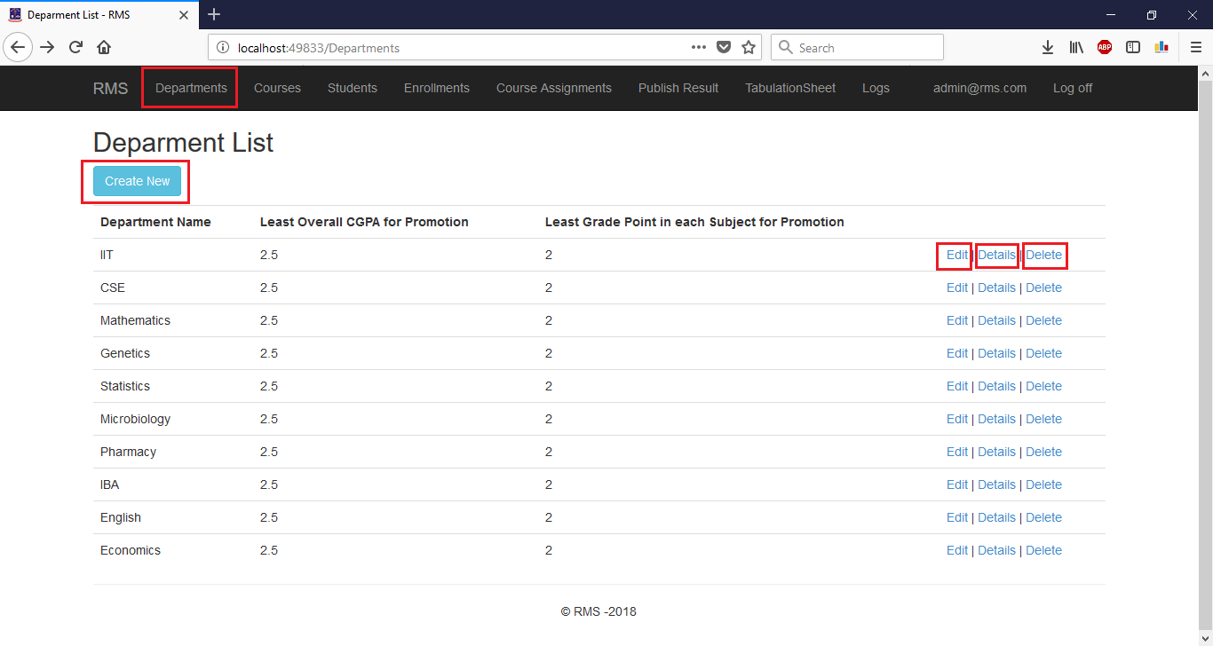

Figure 11: Department Create, Edit, Details, Delete

Create

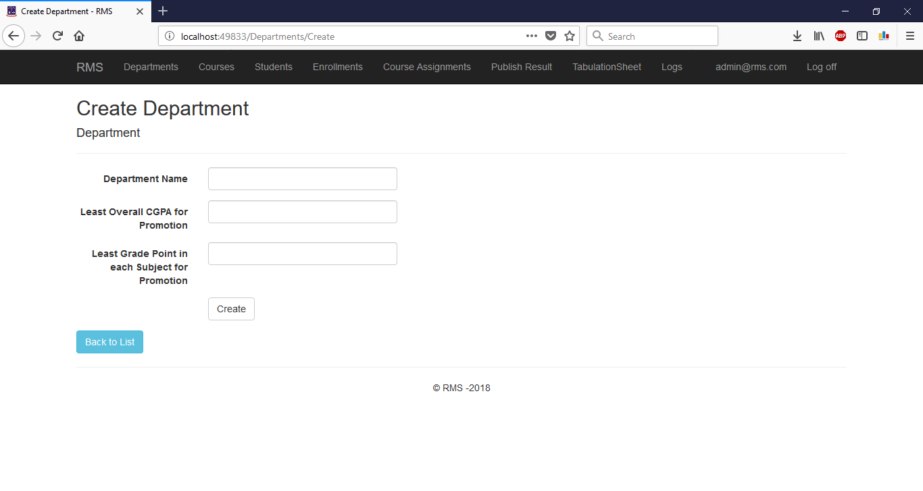

Figure 12: Department Create Form

EDIT

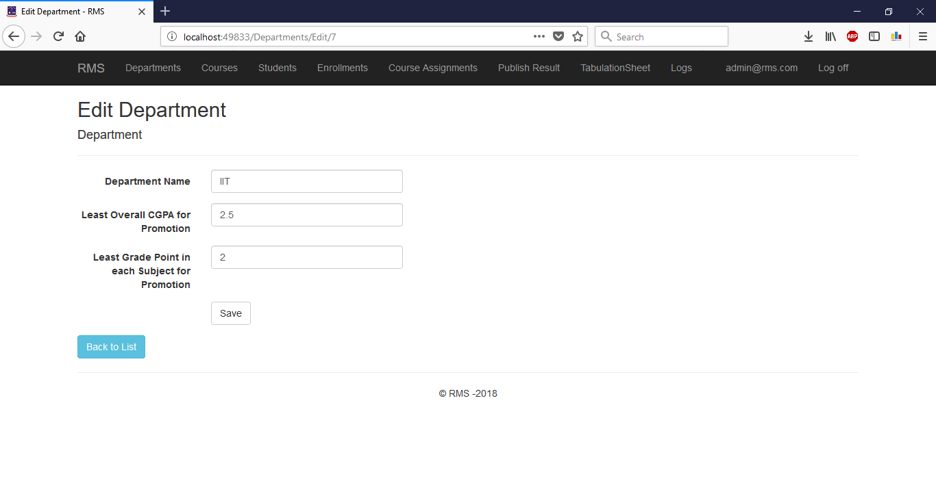

Figure 13: Department Edit Form

DeTAILs

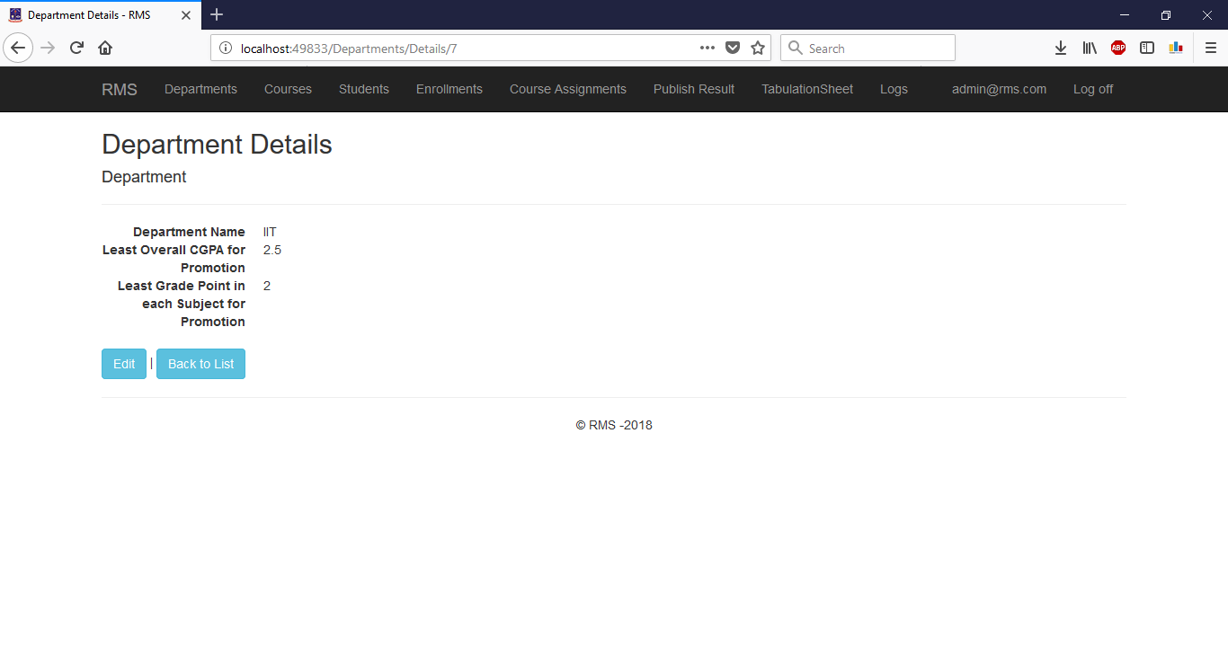

Figure 14: Department Details

DELETE

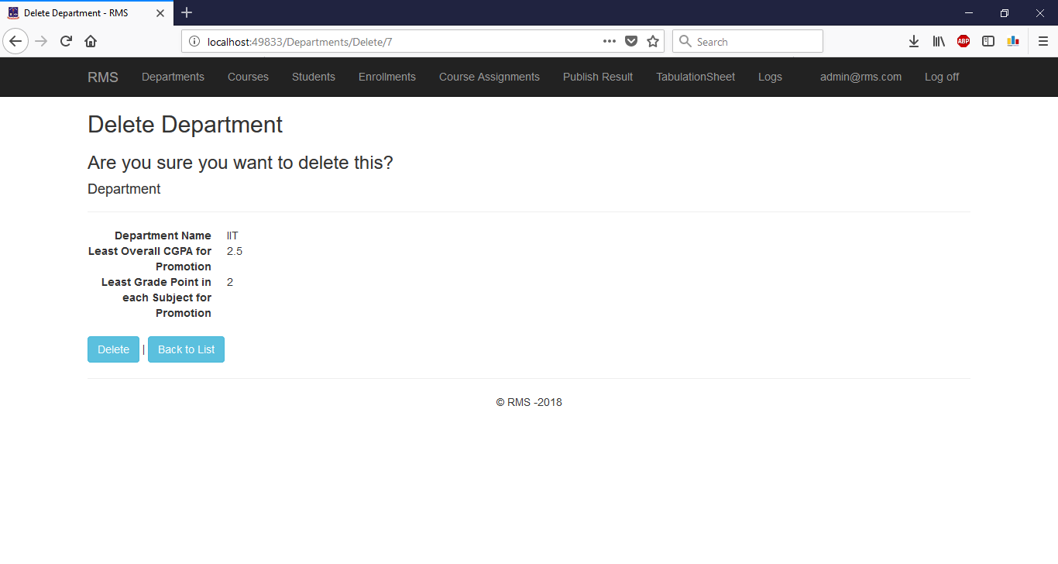

Figure 15: Department Delete Form

## COURSES

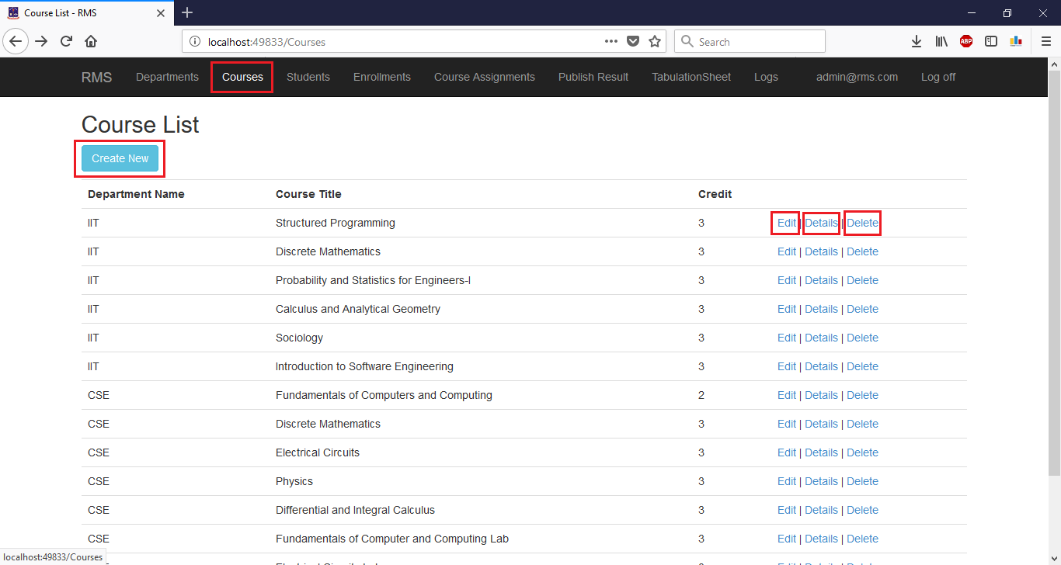

Figure 16: Course Create, Edit, Details, Delete

Create

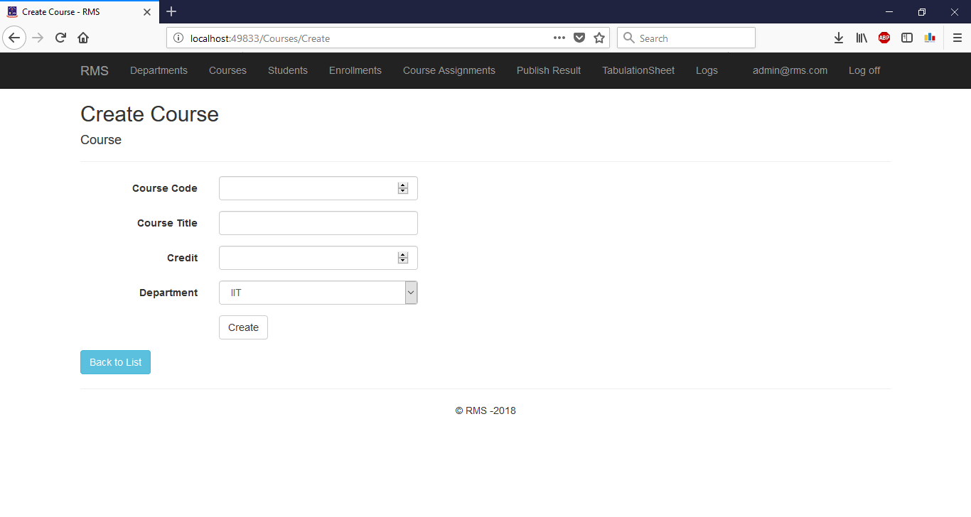

Figure 17: Course Create Form

EDIT

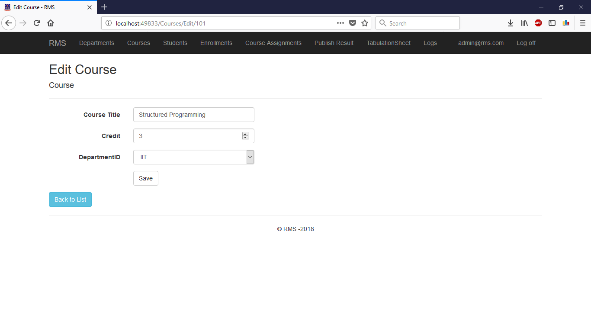

Figure 18: Course Edit Form

DeTAILs

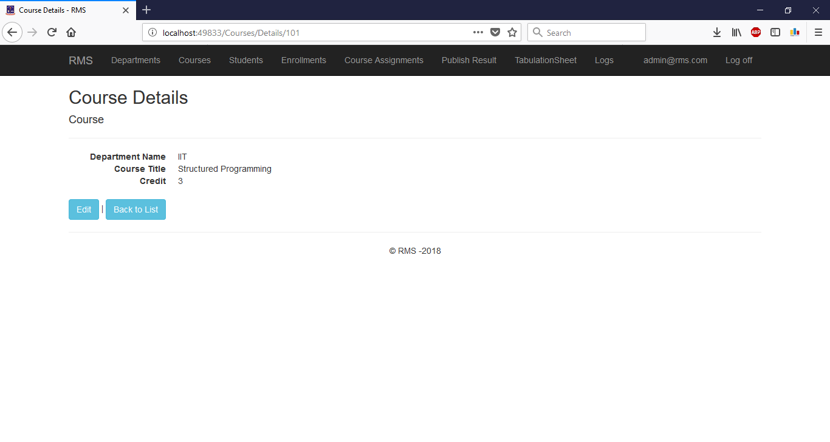

Figure 19: Course Details

DELETE

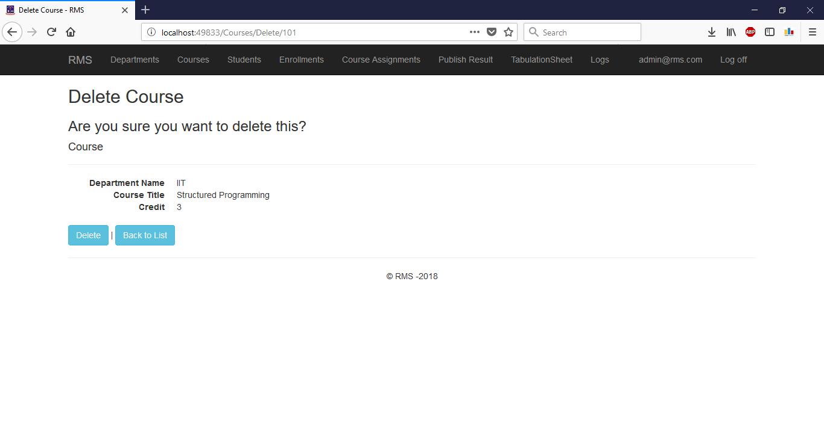

Figure 20: Course Delete

## STUDENTS

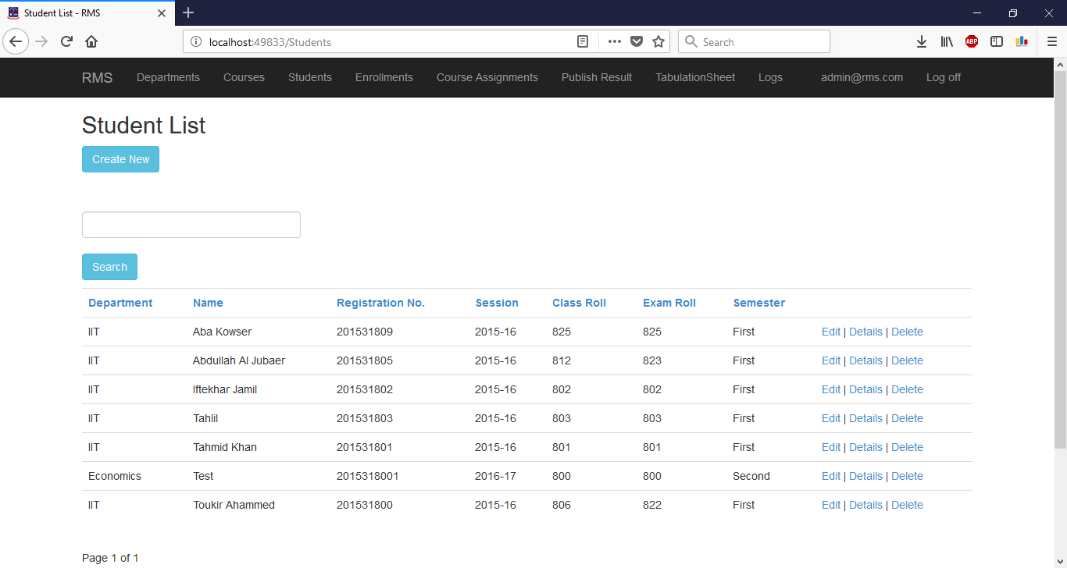

Figure 21: Student Create, Edit, Details, Delete, Search

Create

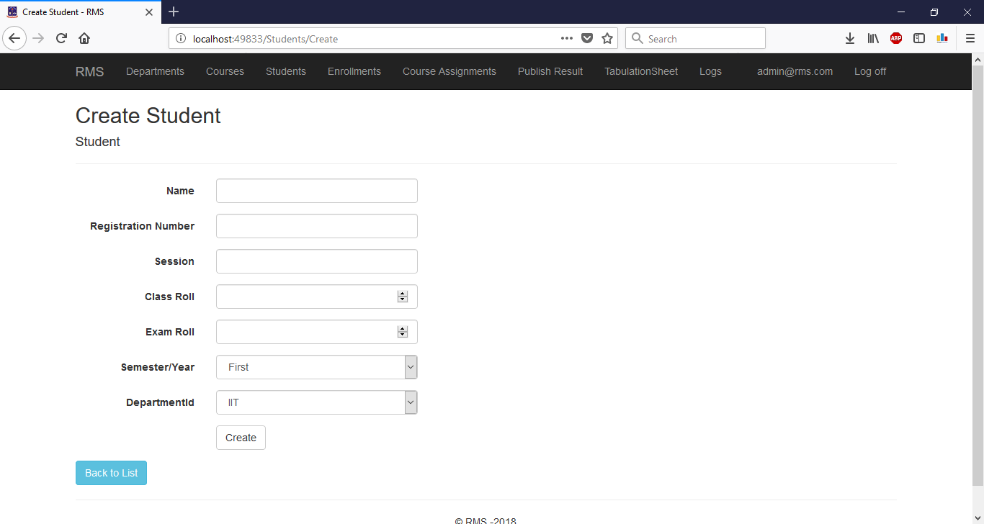

Figure 22: Student Create Form

EDIT

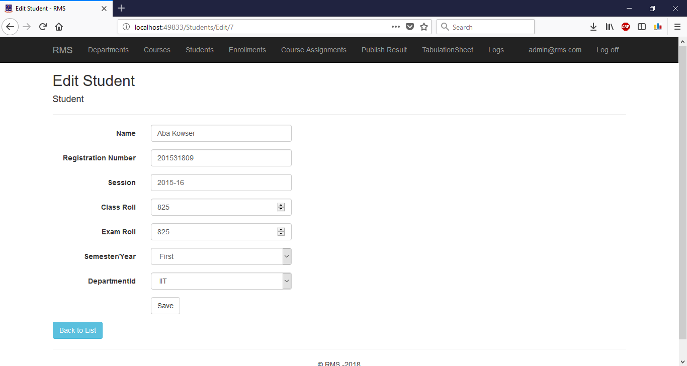

Figure 23: Student Edit Form

DeTAILs

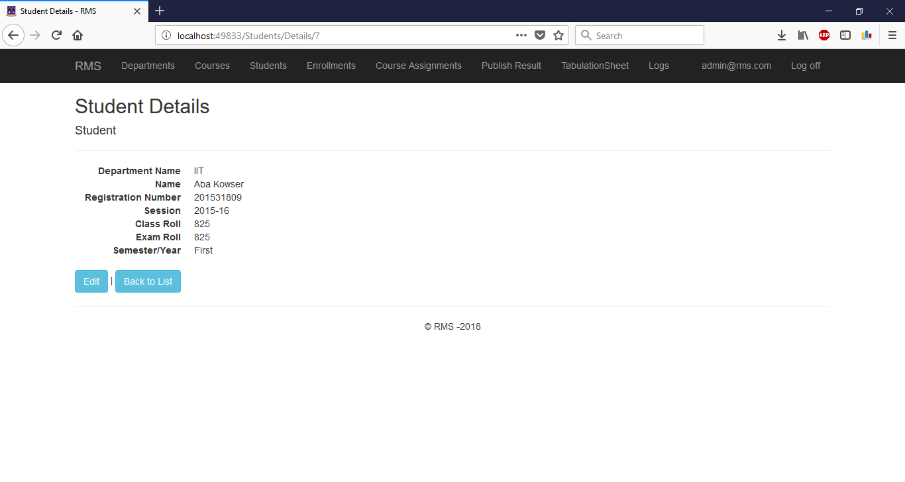

Figure 24: Student Details

DELETE

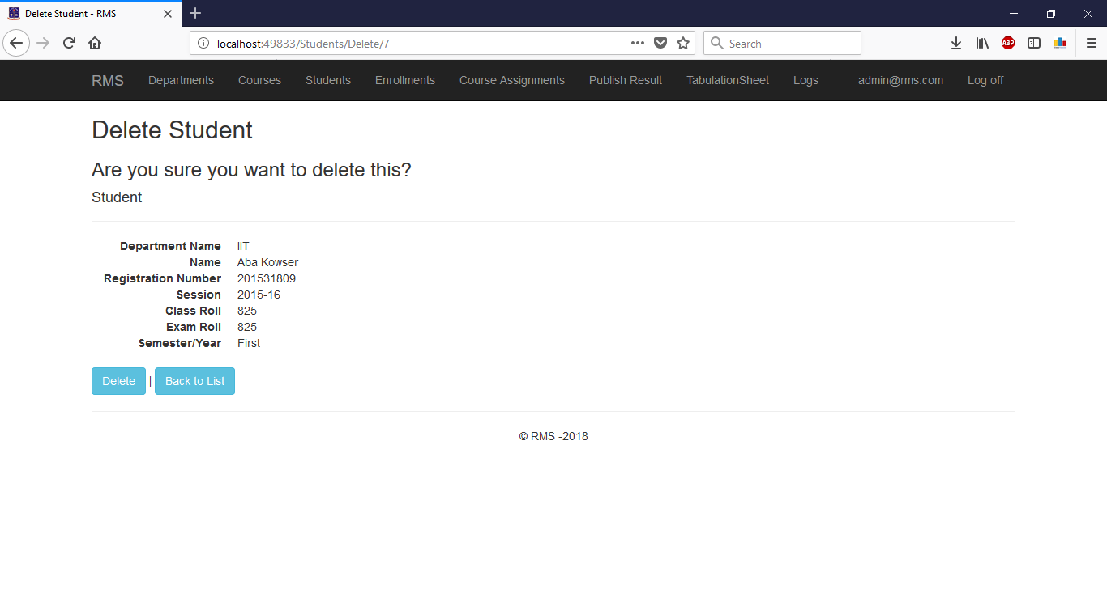

Figure 25: Student Delete Form

SeArch

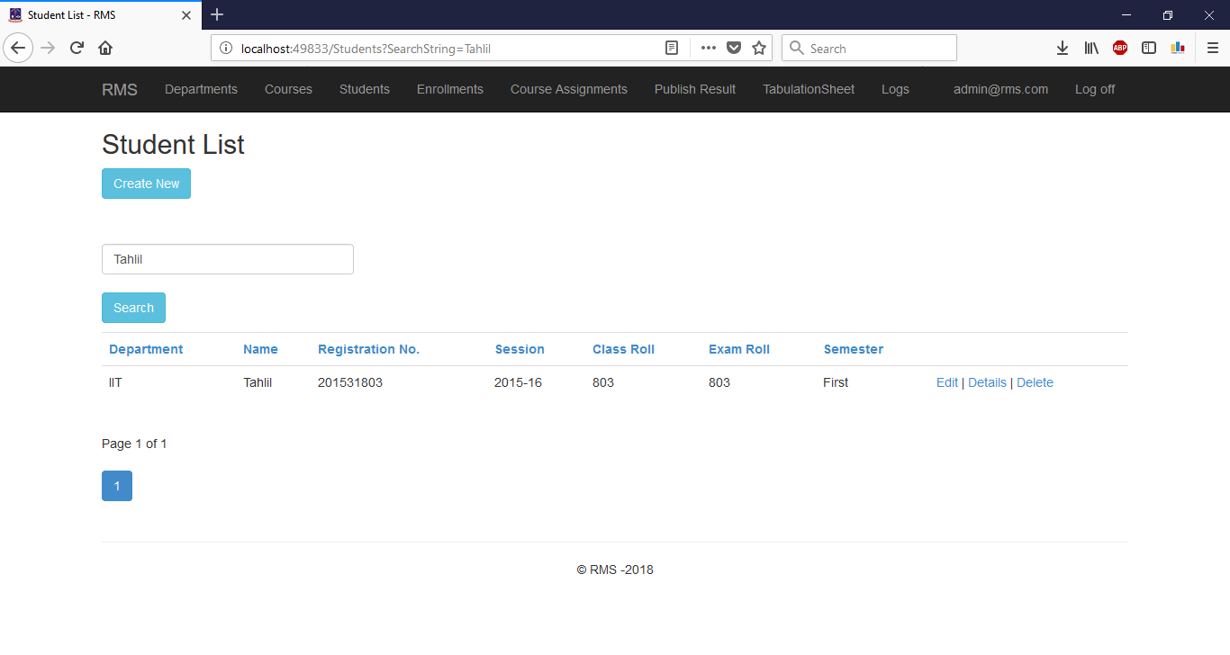

Figure 26: Student Search

## ENROLLMENTS

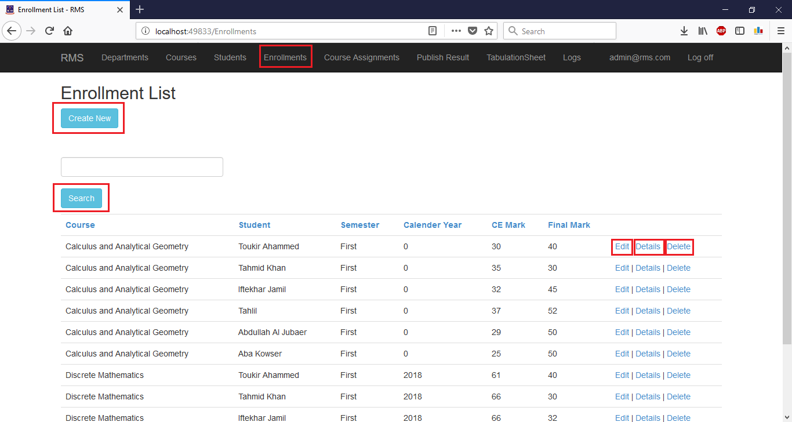

Figure 27: Enrollment Create, Edit, Details, Delete, Search

Create

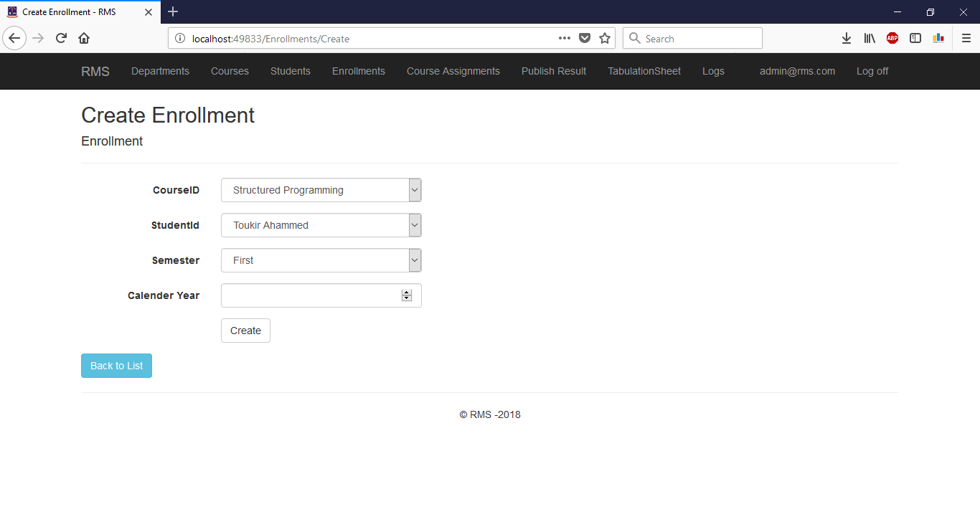

Figure 28: Enrollment Create Form

EDIT

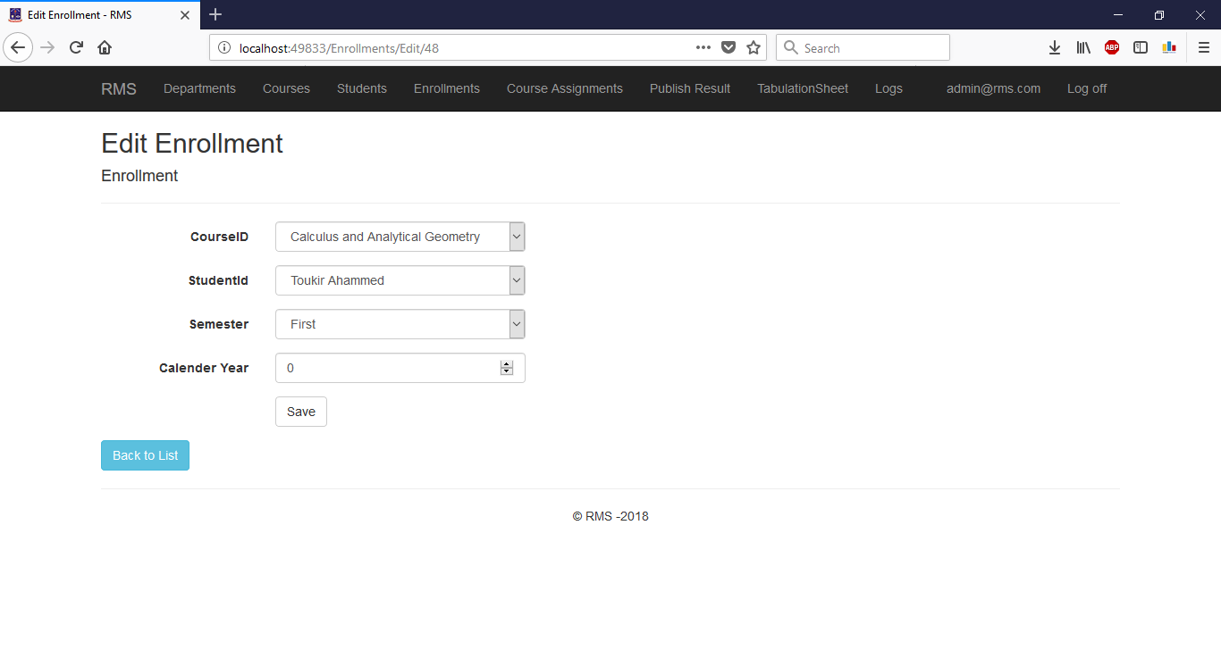

Figure 29: Enrollment Edit Form

DeTAILs

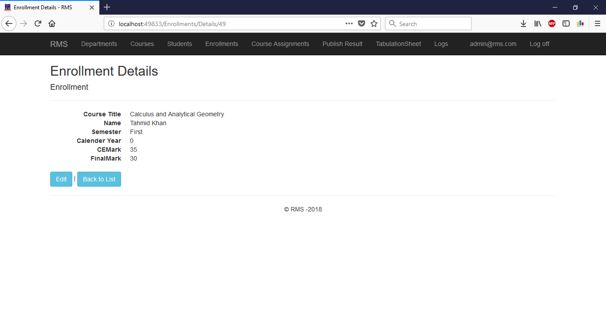

Figure 30: Enrollment Details

DELETE

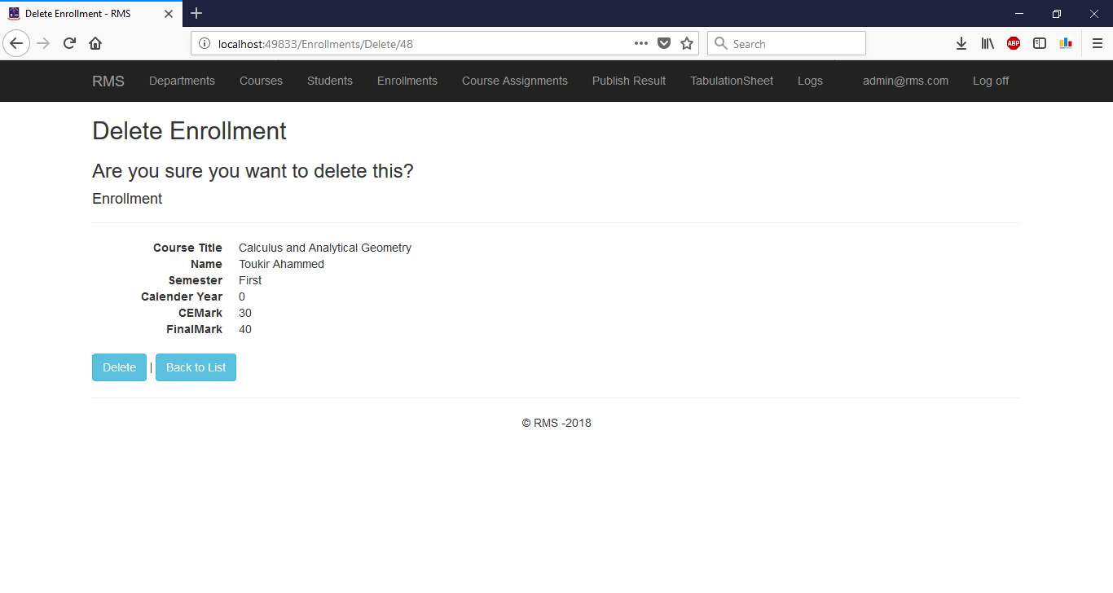

Figure 31: Enrollment Delete Form

Search

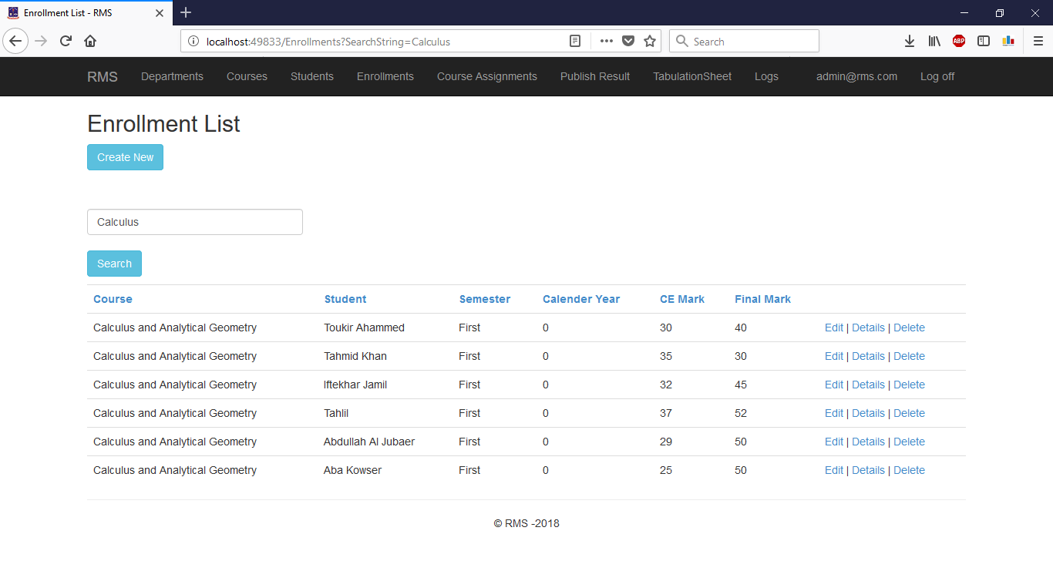

Figure 32: Enrollment Search

## COURSE ASSIGNMENTS

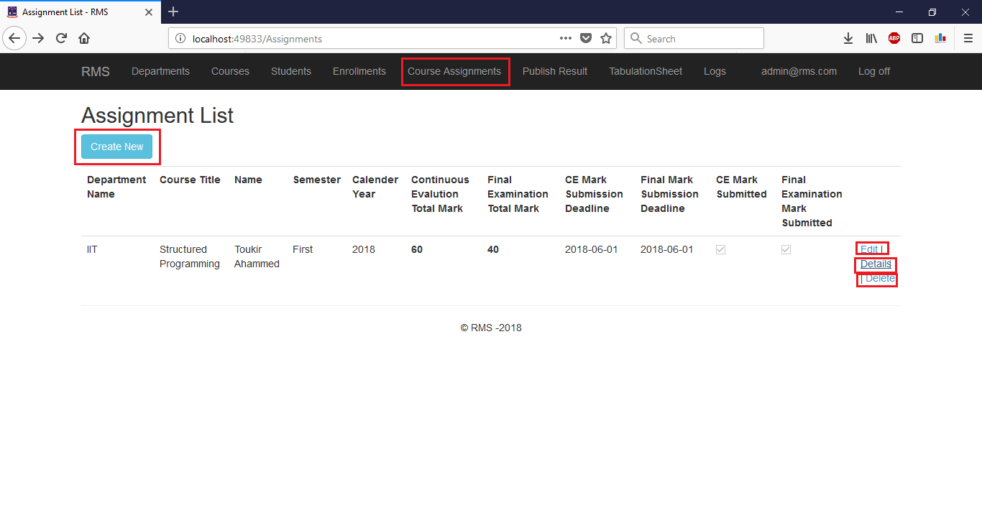

Figure 33: Course Assignment Create, Edit, Delete, Details

Create

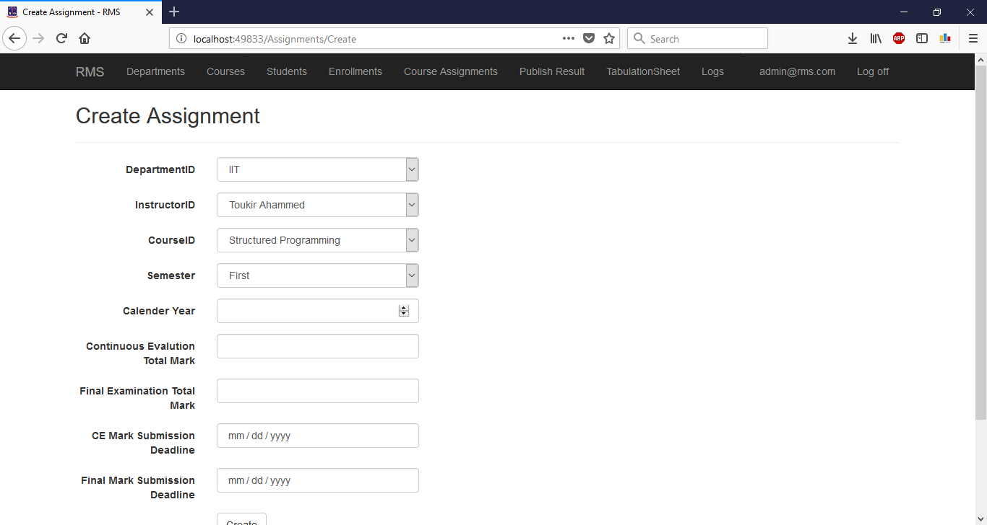

Figure 34: Course Assignment Create Form

EDIT

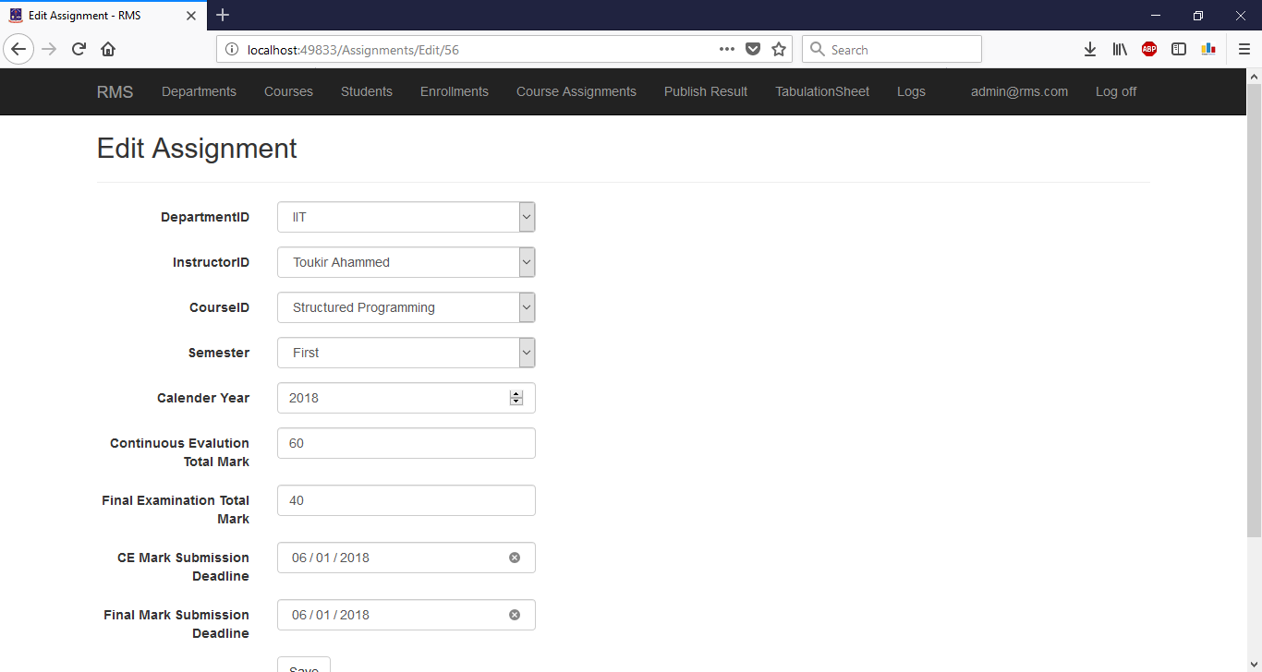

Figure 35: Course Assignment Edit Form

DeTAILs

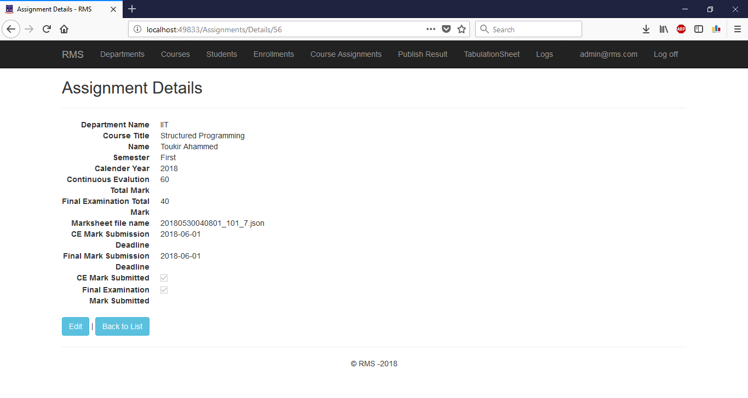

Figure 36: Course Assignment Details

DELETE

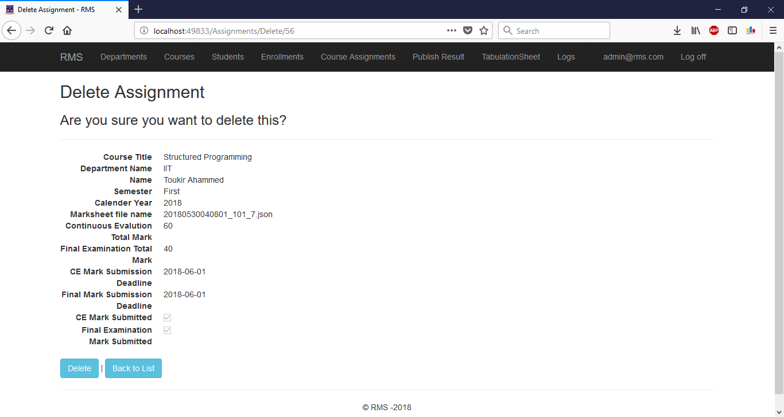

Figure 37: Course Assignment Delete form

## PUBLISH RESULT

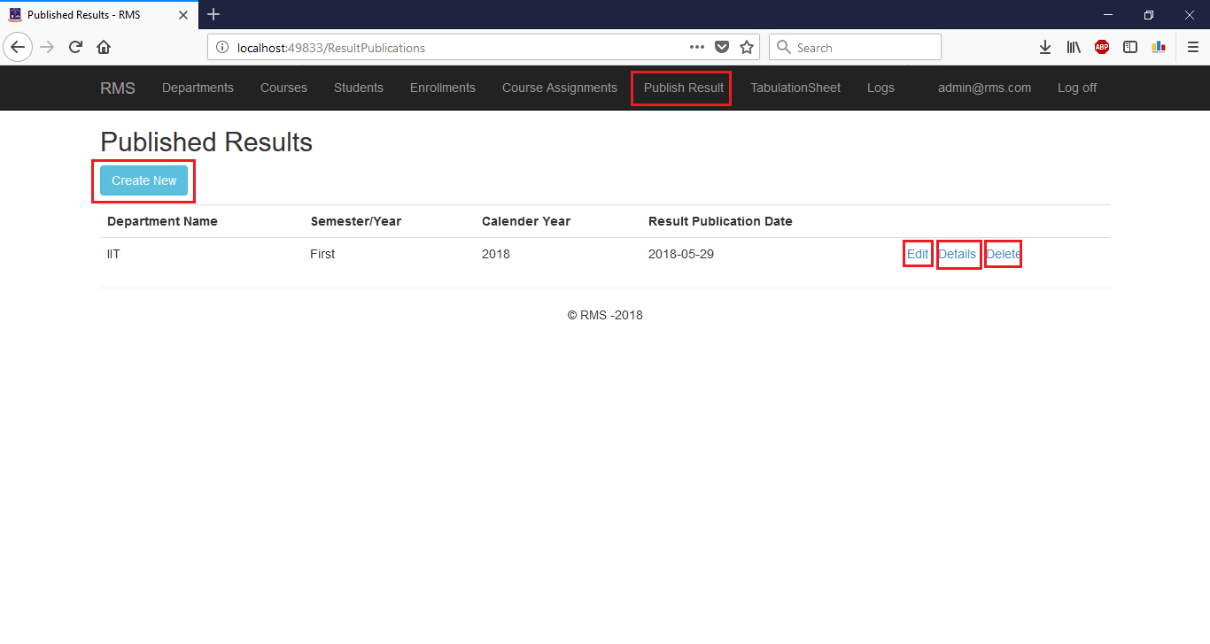

Figure 38: Publish Result

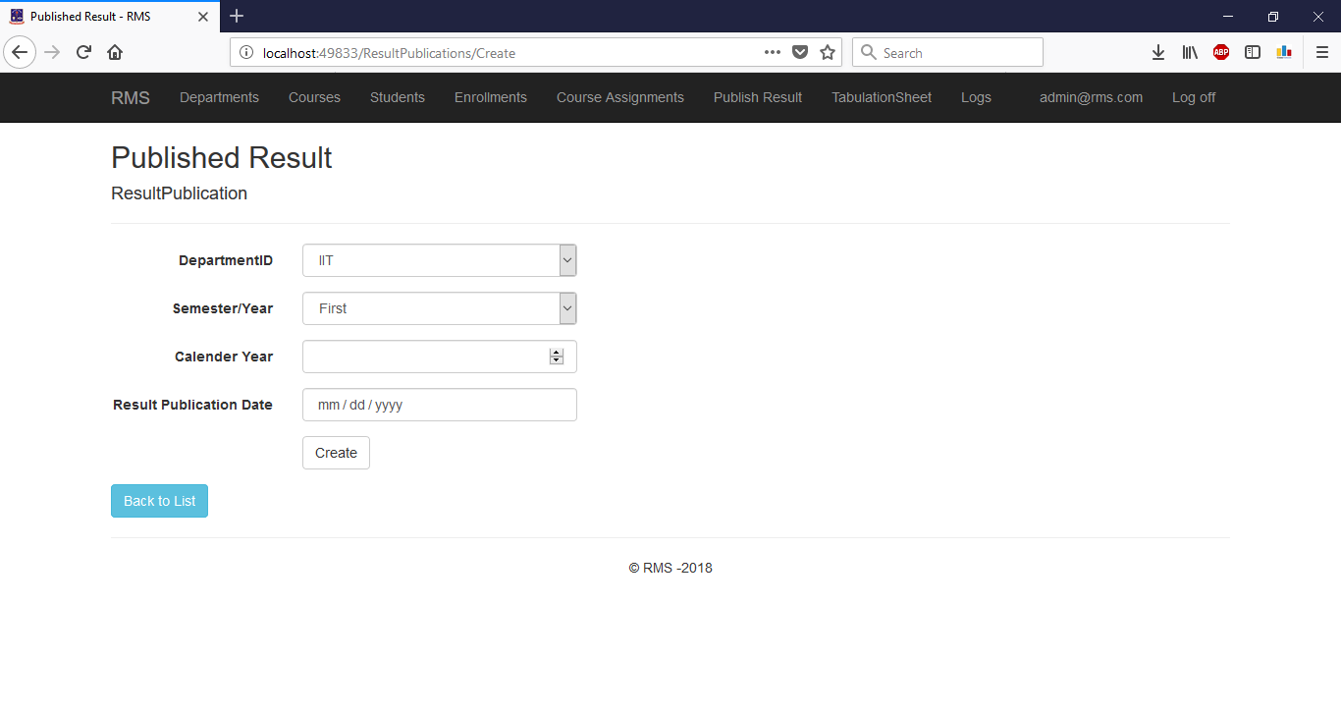

Figure 39: Result Publication Form

## TabulationSheet

Generate

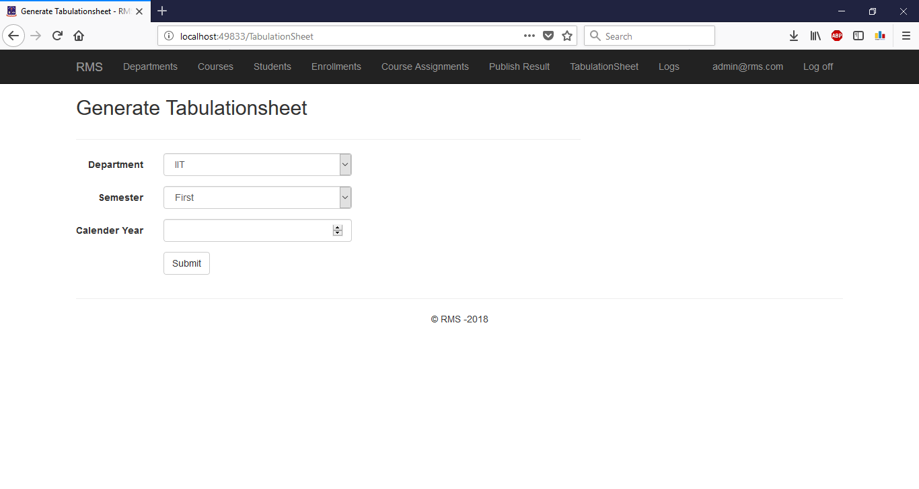

Figure 40: Tabulation sheet Generation Form

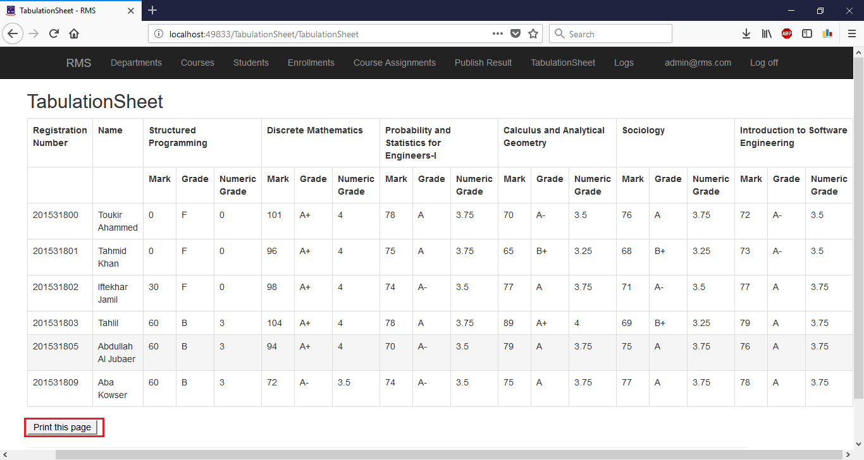

Figure 41: Generated Tabulation Sheet with Print Option

## LOGS

View and Search

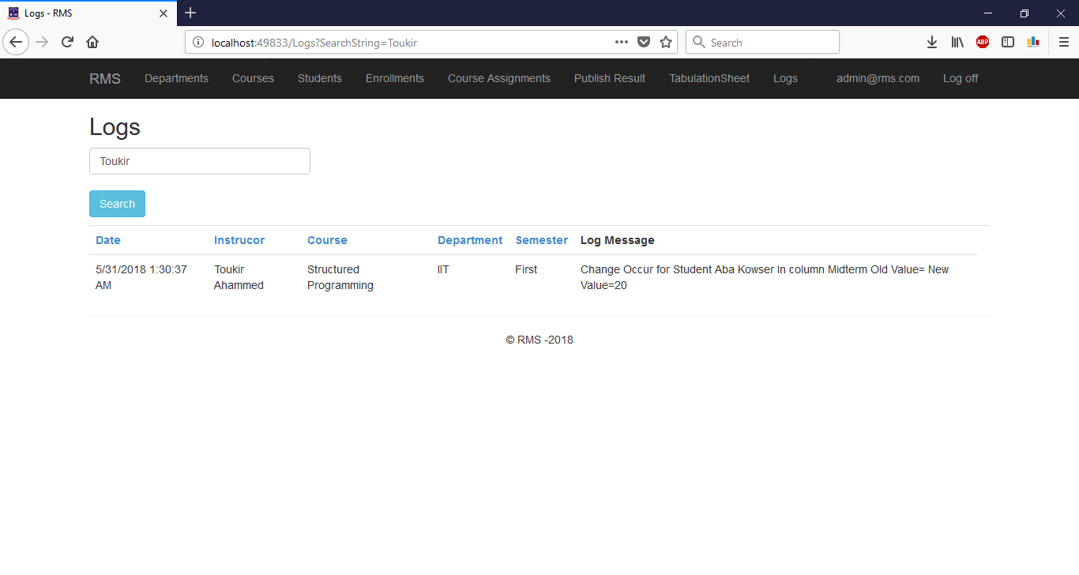

Figure 42: View and Search Logs

# Instructor Panel

## MyCOURSES

Course List

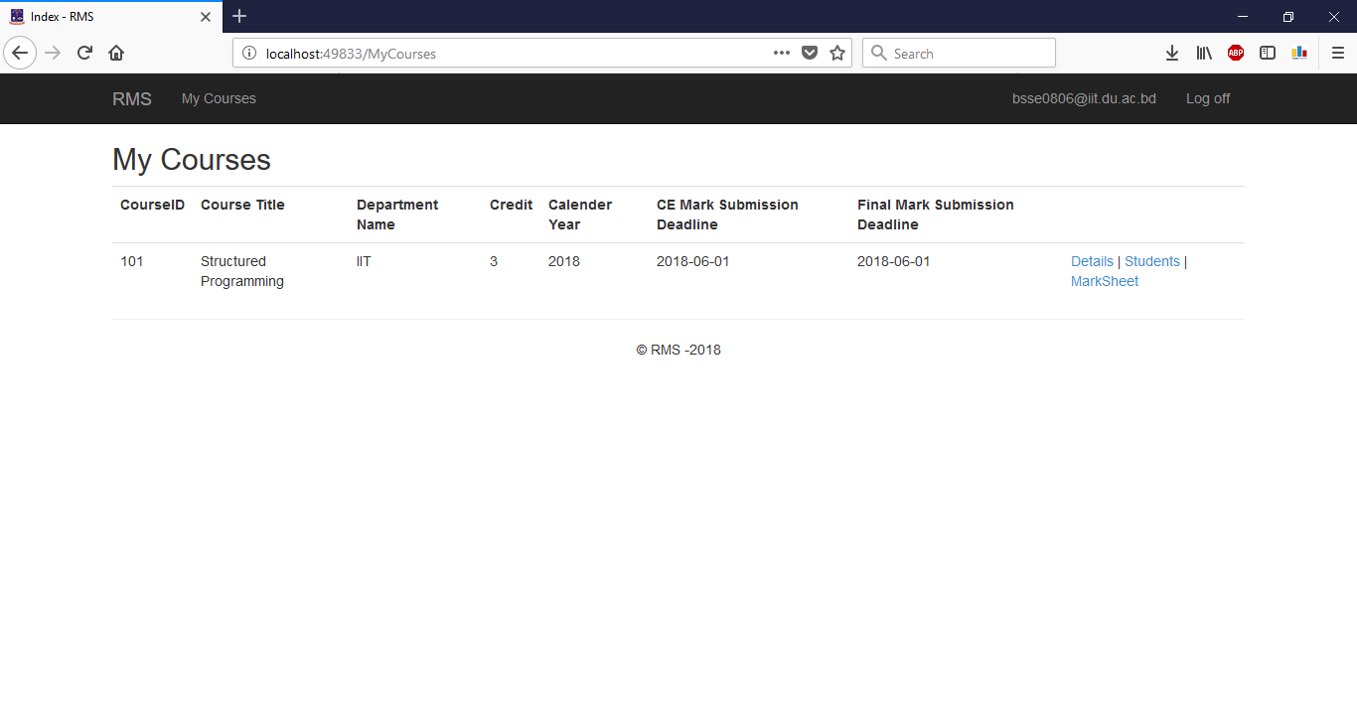

Figure 43: Instructor Courses List

Course Details

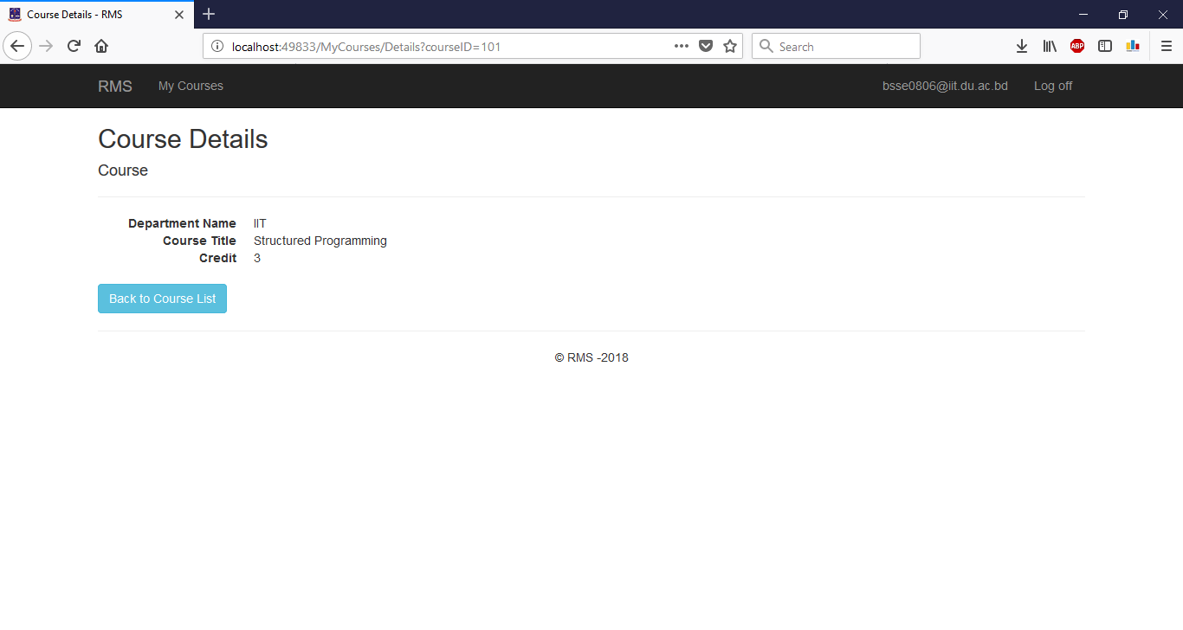

Figure 44: See Course Details

Student List

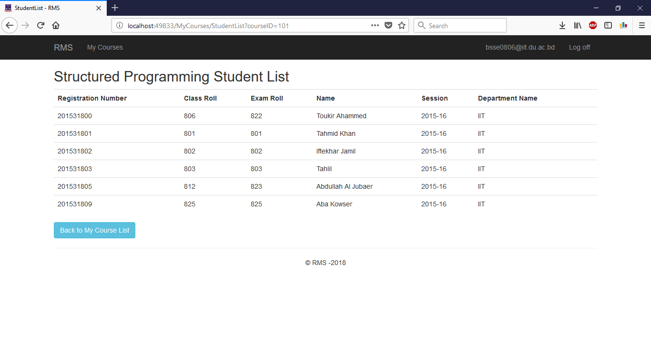

Figure 45: See Student List

Mark Submission

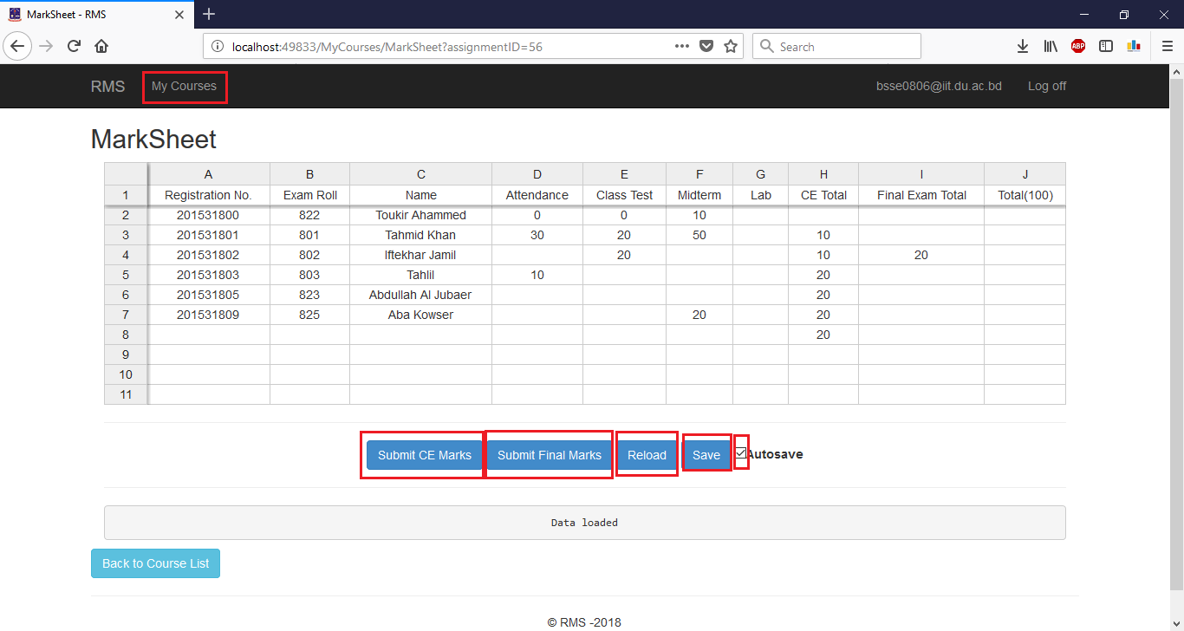

Figure 46: Mark Submission

Manage Spreadsheet

A spreadsheet, is a two-dimensional grid with columns and rows. Look at the spreadsheet below. The column names are letters of the alphabet starting with A, and the rows are numbered chronologically starting with the number one. The cells in the first *row* are A1, B1, C1, and so on. And the cells in the first *column* are A1, A2, A3, and so on. These are called cell names or cell references.

We use **cell references** when creating math formulas or functions. For example, the formula to add the contents of cells B2 and B3 together is: **=**B2+B3.

How to Enter Data into Cells

To enter data into a cell, just click in the cell and begin typing. Cell data can be used as cell reference.

How to Move From Cell to Cell

The arrow keys can be used to move left, right, up, and down from the current cell. Press the Enter key to move to the cell immediately below the current cell and press the Tab key to move one cell to the right.

How to Select Cells

There are a variety of ways to select cells in a spreadsheet:

1. To select one cell, click in the cell.
2. To select one or more rows of cells, click on the row number(s).
3. To select one or more columns of cells, click on the column letter(s).
4. To select a group of contiguous cells, click in a corner cell and, with the left mouse button depressed, drag the cursor horizontally and/or vertically until all of the cells you want selected are outlined in black.
5. To select multiple cells that are not contiguous, press and hold the Ctrl key while clicking in the desired cells.

How to Copy Cell Contents

You can copy the contents of a cell as described above but paste and fill multiple adjacent cells. Just highlight the block of cells you want to paste in: click and hold the left mouse button in one corner of the cell range. Still holding the mouse button down, swipe the cursor over to the opposite corner until just the cells you want filled are highlighted.

How to Add and Delete Rows and Columns

To insert a new row in a spreadsheet, right-click on a row number or any cell and click Insert row above or insert row below and to insert a new column in a spreadsheet, right-click on a column number or any cell and click Insert column left or insert column right.

How to Define Formula In Cell

Rows run horizontally and columns run vertically. To remember which is which, think of a column holding up a roof – columns go up-down and thus rows go left-right. Columns are labeled by letters; rows by numbers. The first cell in the spreadsheet is A1 meaning column A, row 1. The columns are labeled A-Z. When the alphabet runs outs, Excel places another letter in front: AA, AB, AC… AZ, BA, BC, BC, etc.

You use functions by typing them directly in or using the function wizard. The function wizard opens when you either pick a function from the “Formulas” menu from the “Function Library.” Otherwise, you can type = in a cell and a handy drop-down menu will allow you to pick a function

The wizard tells you what arguments you need to provide for each function. It also provides a link to online instructions if you need help understanding what the function does and how to use it. For example, if you type =sum into a cell, the in-line wizard shows you what arguments are required for the SUM function.

#NAME? indicates that there is some kind of error. It could be any number of things including:

* bad cell reference
* using letters in math functions
* omitting required arguments
* spelling function name wrong
* illegal math operations like division by 0

The easiest way to select the arguments in a calculation is to use the mouse. You can add to or remove from the list of arguments to the function by enlarging or making smaller the box that Spreadsheet draws when you move the mouse or click in another cell.

We have clicked on the top of the square drawn by Excel to take “airline tickets” out of the budget. You can see the crosshair symbol that you can draw to make the selected range larger or smaller.

Calculation Operators

There are two types of operators: math and comparison.

|  |  |
| --- | --- |
| **Math Operator** | **Definition** |
| + | addition |
| – | subtraction, or negation, e.g., 6 * -1 = -6 |
| * | multiplication |
| / | division |
| % | percent |
| ^ | exponent, e.g. 24 = 2 ^ 4 = 2 * 2 * 2 * 2 =16 |

There are other operators not related to mathematics like “&” which means concatenate (join end-to-end) two strings.

Operator Order Precedence

Order precedence is an idea from mathematics. Excel has to follow the same rules as mathematics. This topic is more complicated, so take a breath and let’s dive in.

Order precedence means the order in which the computer calculates the answer.

So you have to understand the order precedence when you write a formula.

Generally, you can say this:

1. Spreadsheet first evaluates items in parentheses working inside out.
2. It then uses the order precedence rules of mathematics.
3. When two items have the same precedence, Excel works left to right.

The precedence of math operators is shown below, in descending order.

|  |  |
| --- | --- |
| ( and ) | When parentheses are used, they override the normal rules of precedence. This means that Excel will do this calculation first. We explain this further below. |
| – | Negation, e.g., -1. This is the same as multiplying a number by -1. -4 = 4 * (-1) |
| % | Percent, means multiply by 100. E.g., 0.003 = 0.3%. |
| ^ | Exponent, e.g., 10 ^ 2 = 100 |
| * and / | Multiply and divide. How can two operators have the same precedence? It just means that if a formula has two more operators with the same precedence, then the calculation is done left to right. |
| + and – | Addition and subtraction. |

There are other precedence rules related to strings and reference operators.

How to Merge Cell

Merging cells is often used when a title is to be centered over a particular section of a spreadsheet. When a group of cells is merged, only the text in the upper-leftmost box is preserved.

To merge a group of cells:

1. Highlight or select a range of cells.
2. Right-click on the highlighted cells and select Merge Cells

reLoad

Click “Reload” button to reload data. It is mandatory to reload data before submitting

Save

Click “Save” button to save the data.

Autosave

Check the autosave checkbox to automatically save changed data.

SUbmit Continuous Evalution Marks

Click “Submit CE Marks” to submit continuous evaluation marks.

Submit Final Examination MaRk

Click “Submit Final Marks” to submit final examination marks.

# Student Panel

## Checking Result

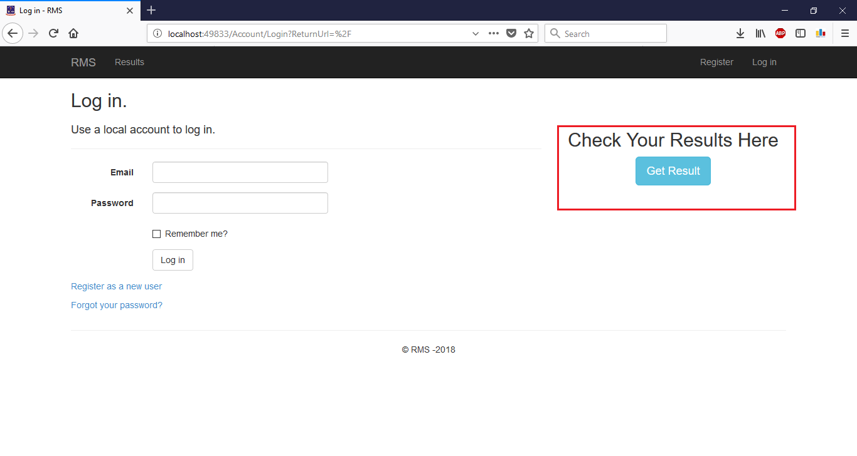

Figure 47: Checking Result

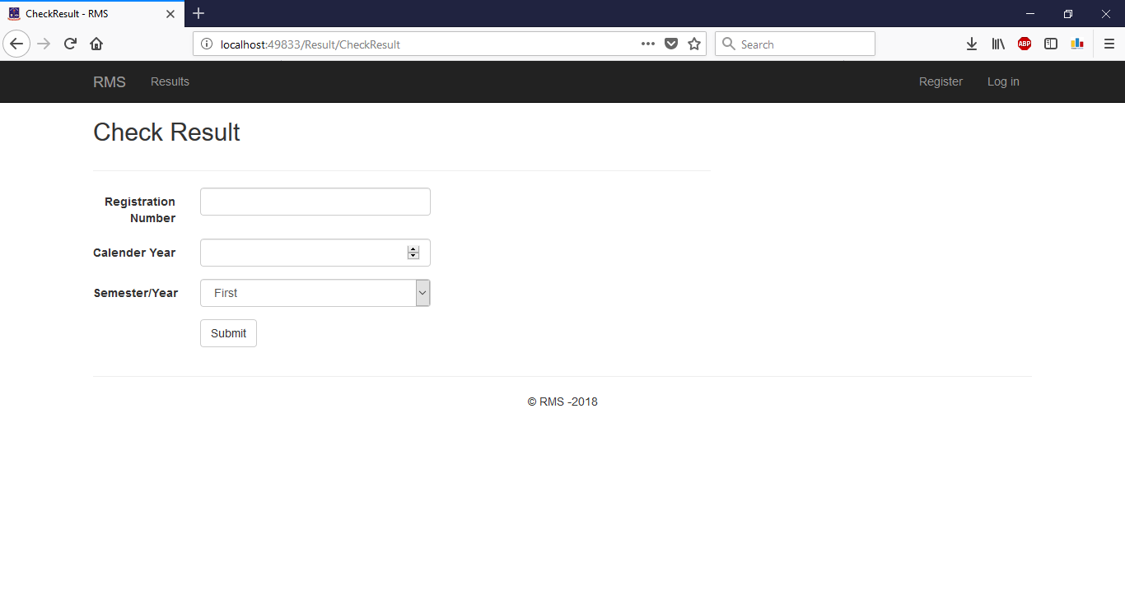

Figure 48: Result Checking Form

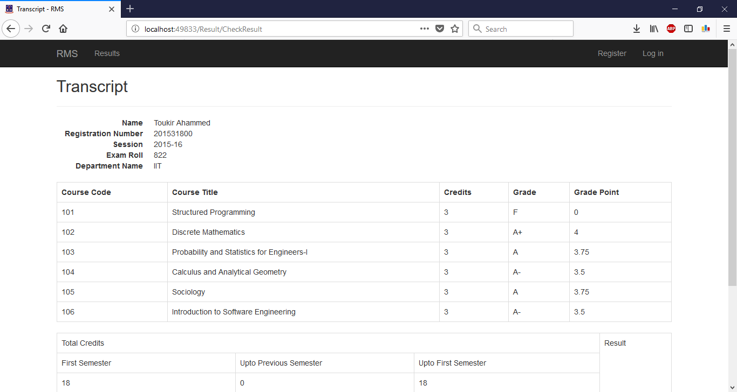

Figure 49: Viewing Result

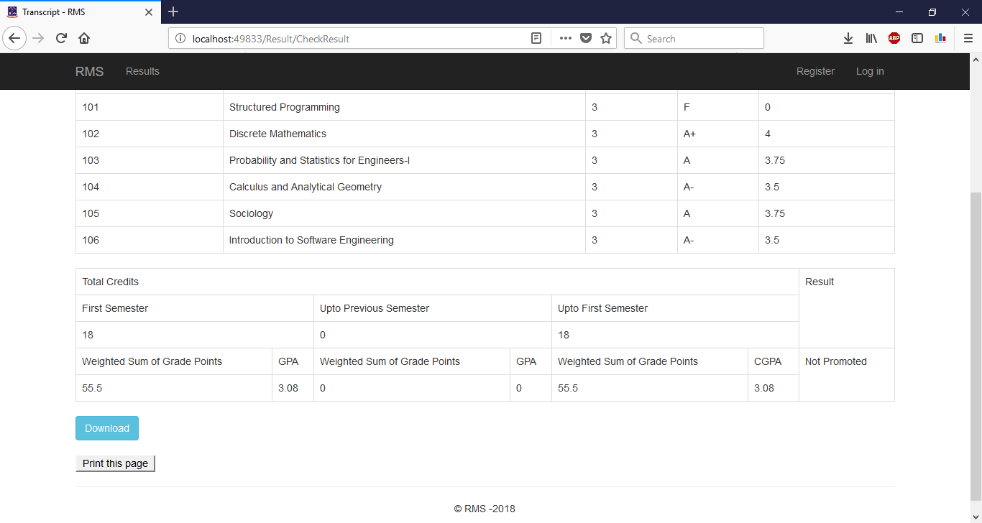

Figure 50: Downloading and print page

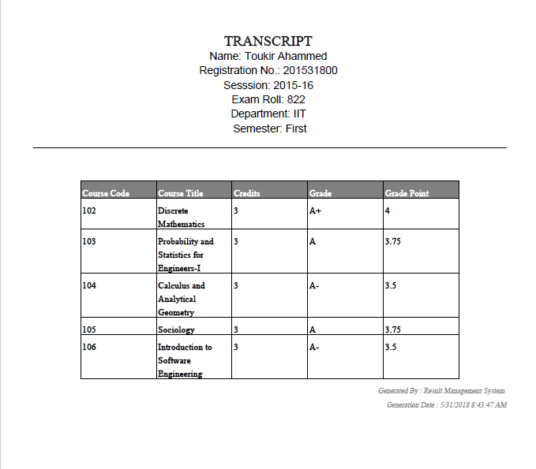

Figure 51: Sample Downloaded Transcript